**The Cay- chapters 11 and 12 Name: ____________________________**

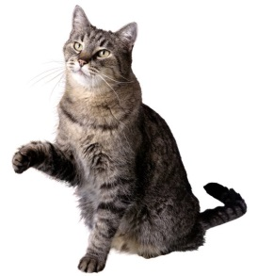**Common Core RL.3 plot and character change**

Explain what course of action you would take if you were in Phillip’s situation with Stew Cat missing and Timothy saying that maybe the cat is the d’jumbi. Explain why this would be a more effective course of action than the way Phillip reacted.

___________________________________________________________________

_____________________________________________________________________________________

_____________________________________________________________________________________

_____________________________________________________________________________________

_____________________________________________________________________________________

_____________________________________________________________________________________

_____________________________________________________________________________________

_____________________________________________________________________________________

_____________________________________________________________________________________

_____________________________________________________________________________________

_____________________________________________________________________________________

_____________________________________________________________________________________

_____________________________________________________________________________________

C:\Users\stacy.bush\AppData\Local\Microsoft\Windows\Temporary Internet Files\Content.IE5\1B783FIP\MC900050982[1].wmf________________________________________________________________

________________________________________________________________

________________________________________________________________

________________________________________________________________

________________________________________________________________